App Logo:

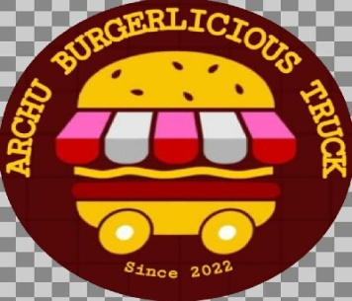

App Name:

Archu Burgerlicious Truck

App Overview:

A balanced diet is a burger in each hand. It is safer and healthier alternative to street food.

Short Description:

A balanced diet is a burger in each hand. It is safer and healthier alternative to street food.

App description:

Archu Burgerlicious Truck can do the following:

\*View the orders received in the past hours.

\*Check the number of available dishes.

\*Check the total customers using the food truck app.

\*See the total orders placed in the last 24 hours.

\*Set Offers for The Day & Update The Locations As You Move.

\*Paperless Transactions

\*To provide quality, authentic food to our community in a convenient and affordable way in order to enhance the quality of our customers’ lives.

Archu Burgerlicious Truck makes it easy for customers to order food. Plus, Archu Burgerlicious Truck app users can easily find out the best deals on food. Moreover, food truck owners can introduce themselves as well as their specialties in food in front of the users via a food truck app. Archu Burgerlicious Trucks Can Experiment with Location.

Support email:

Archukumar1413@gmail.com